Confectionary Sales Analysis

Summary:
This project involved developing a comprehensive Power BI dashboard to analyze confectionary sales data across multiple dimensions including geography, products, time periods, and sales personnel performance. The dashboard transforms raw sales data into actionable insights, enabling data-driven decision-making for sales strategy and resource allocation.
Total Sales Analyzed: $19.79M across multiple countries and products
Key Achievement: 54.30% Year-over-Year growth identified and visualized

Problem Statement
Business Challenges
The confectionary sales organization faced several critical challenges:
- Lack of Sales Visibility: Sales data existed in raw format without clear visualization of performance trends, making it difficult for management to quickly assess business health
- Regional Performance Gaps: No clear understanding of which countries were driving revenue versus underperforming markets
- Product Performance Analysis: Inability to identify top-performing confectionary products and their contribution to overall sales
- Sales Team Accountability: Difficulty in tracking individual sales representative performance and identifying top performers versus those needing support
- Trend Identification: No mechanism to identify seasonal patterns, growth trends, or declining performance periods
- Data-Driven Decision Making: Management relied on intuition rather than concrete data insights for strategic planning

Dashboard Analysis:
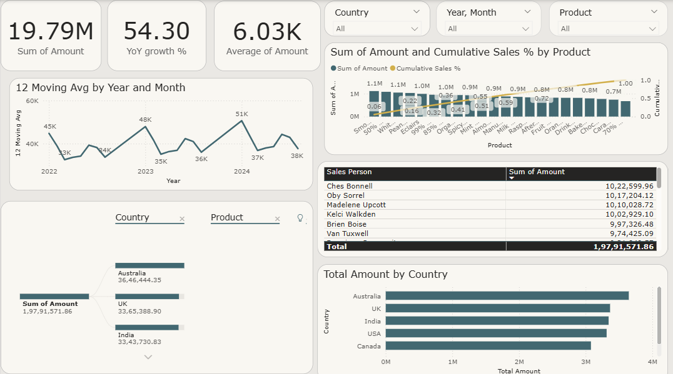
A comprehensive Power BI dashboard was created featuring:
Key Performance Indicators (KPIs)
- Total Sales Amount: Overall total sales amount from 2022 to 2024 ($19.79M)
- YoY Growth Rate: Year-over-year performance comparison (54.30% growth)
- Average Transaction Value: Per-transaction sales metrics ($6.03K)

Let’s deep dive into different analytics:
12 Month Moving Avg by Year and Month:
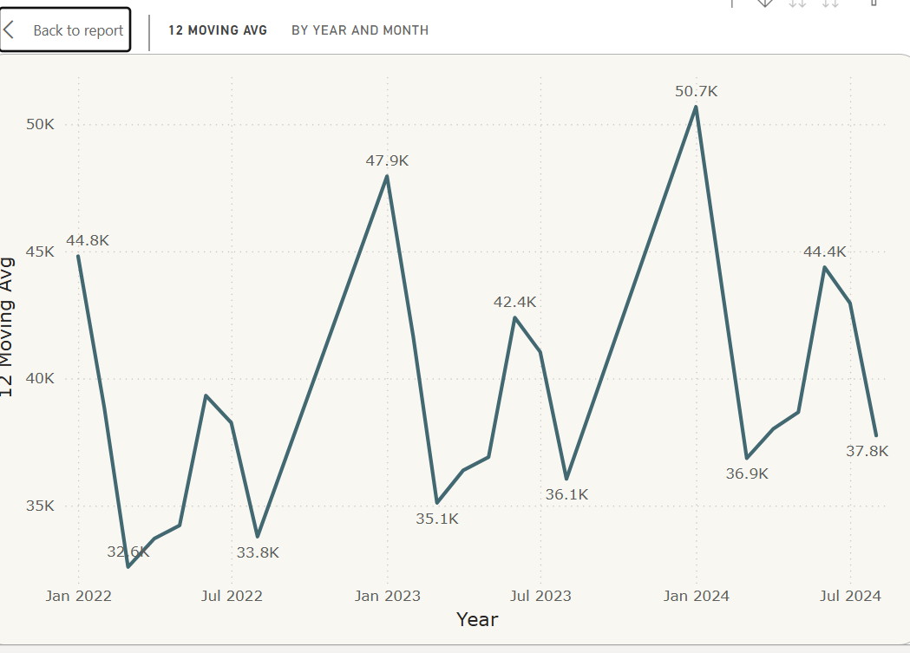
This line chart shows the 12-month moving average of sales year by month, smoothing out short-term fluctuations to reveal the underlying trend. (In this data, we don’t have q4 data as it was not available)
What story does this chart tell:
- There is high spikes in month of January and June, meaning we should prepare ourselves logistically to satisfy the demand.
- Sales show a generally upward trajectory over time, confirming sustained growth. That means we can focus more on competition analysis and customer demographics analysis to better optimize and increase sales.

Product Performance Analysis and Cumulative Sales%
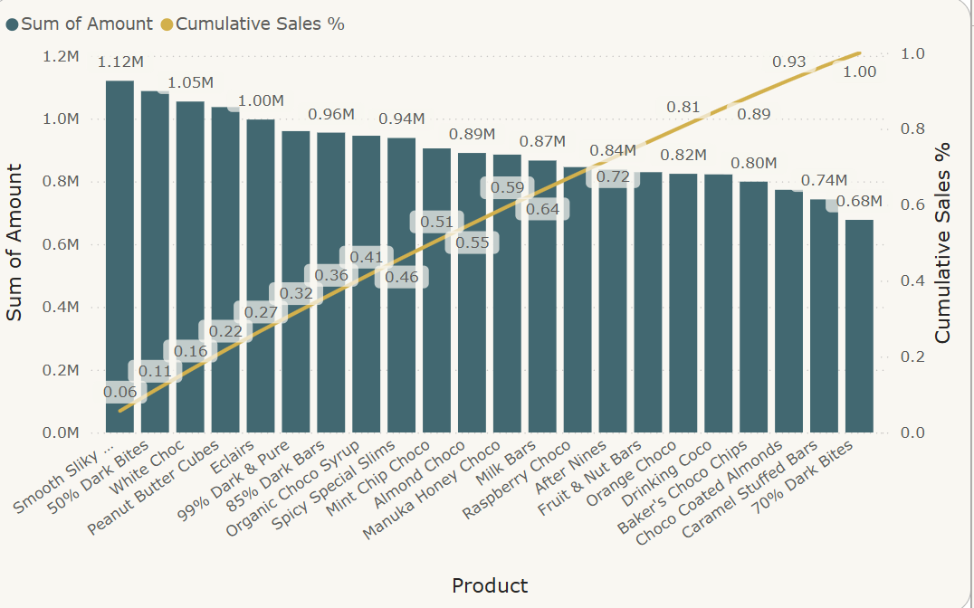
This bar and line combination chart displays total sales by product, along with a cumulative sales percentage (Pareto analysis).
Story told by the chart:
- Smooth Silky chocolate is the highest performing product which has brought highest revenue.
- The cumulative sales% line shows gradual growth which shows the product portfolio is diversified, meaning every product is contributing to revenue almost equally, there is no dependency on any specific set of products.
- From this analysis, we can also consider cost data to further analyze the highest profit-making product.

Salesperson Performance:
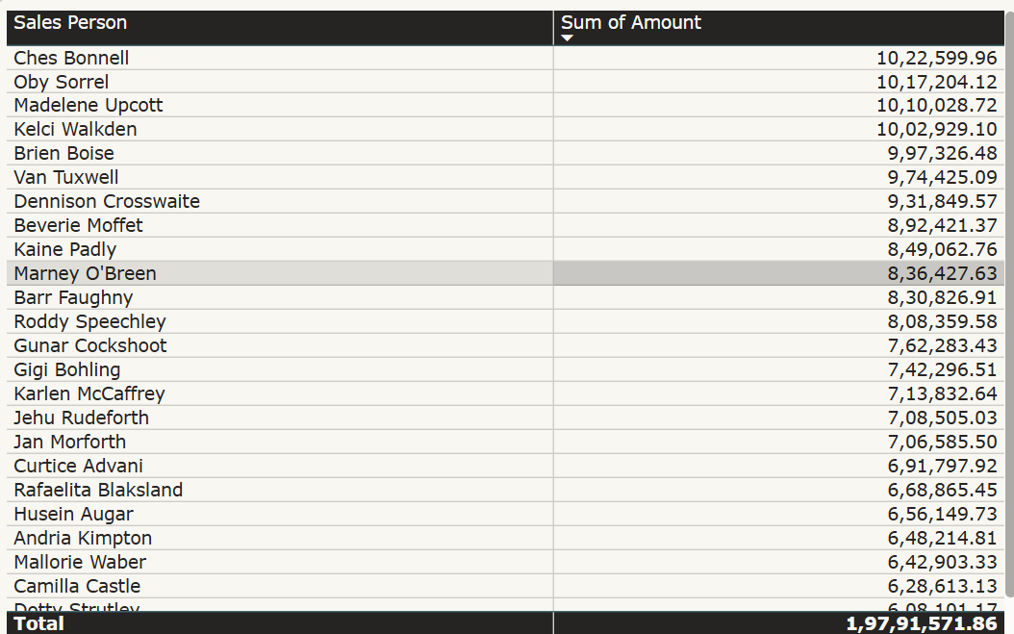
The table ranks salespeople by total sales amount.
Story told by the table:
- Ches Bonnell is the highest performing salespeople of all time from 2022 to 2024.
- Sales contributions are uneven, highlighting opportunities for coaching or best-practice sharing.

Total Sales by Country:
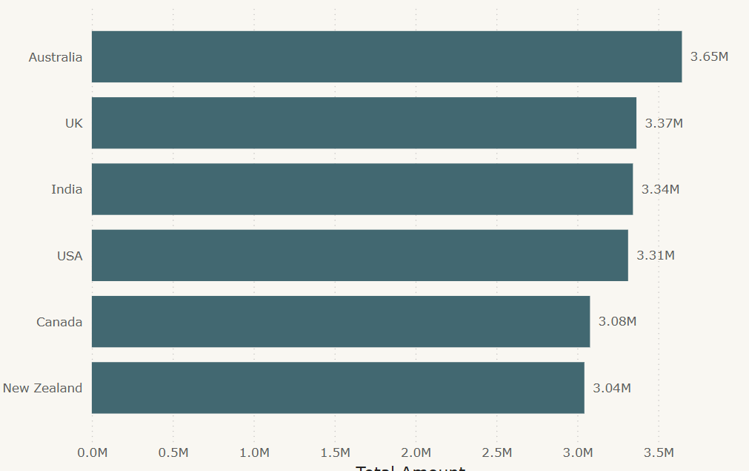
This horizontal bar chart compares total sales across countries.
Story told by the chart:
- Certain countries (such as Australia and the UK) lead in total revenue contribution.
- Sales distribution across regions is relatively balanced, reducing dependency on a single market.
- Slight performance gaps between countries indicate potential for targeted regional growth strategies.

Sales Channel Analysis:
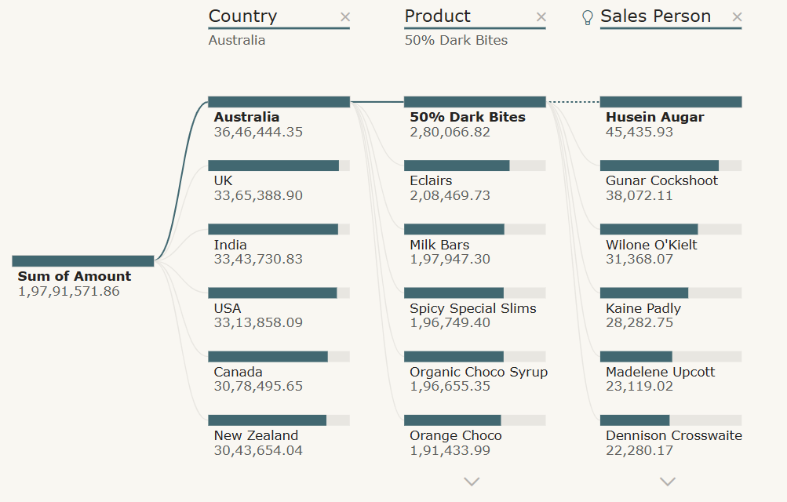
This is a decomposition tree which shows how Sales Channel Analysis:
- This tree shows how Sales Channel Analysis have flowed for country, product, salesperson.
- It will show you detailed analysis of the top performing country, its product, and designated salesperson.

Key Business Insights
1. Strong Overall Growth Trajectory
- Insight: The business achieved 54.30% YoY growth, indicating strong market demand and effective sales strategies
- Implication: Current business model is scalable, and market conditions are favorable
2. Geographic Market Leaders
- Insight: Australia leads with $36.46M in sales, followed by UK ($33.65M) and India ($33.43M)
- Implication: These markets represent core revenue streams and should receive continued investment
3. Sales Team Performance Distribution
- Insight: Top three performers (Ches Bonnell, Oby Sorrel, Madelene Upcott) each generated over $10M
- Implication: Study and replicate best practices from top performers; provide targeted coaching for lower performers
4. Product Portfolio Insights
- Insight: Approximately 20 different confectionary products show varying performance levels
- Implication: Opportunity to optimize product mix by focusing on high performers and evaluating underperformers
5. Temporal Sales Patterns
- Insight: Moving average shows fluctuations in January and June with notable peaks
- Implication: Seasonal patterns exist that can inform inventory planning and marketing campaigns

Recommendations for Future Enhancements
- Plan operations and logistics before the month of January and June to satisfy the demand and to achieve customer satisfaction.
- Sales is increasing gradually, so we can focus on market research and customer demographics.
- Product portfolio is diversified, so we can further work on other products or optimize prices to improve sales.

Conclusion
The Confectionary Sales Analysis Dashboard successfully transformed raw sales data into actionable business intelligence. By providing clear visibility into sales performance across products, geographies, and sales personnel, the dashboard enables data-driven decision-making that directly impacts revenue growth and operational efficiency.

